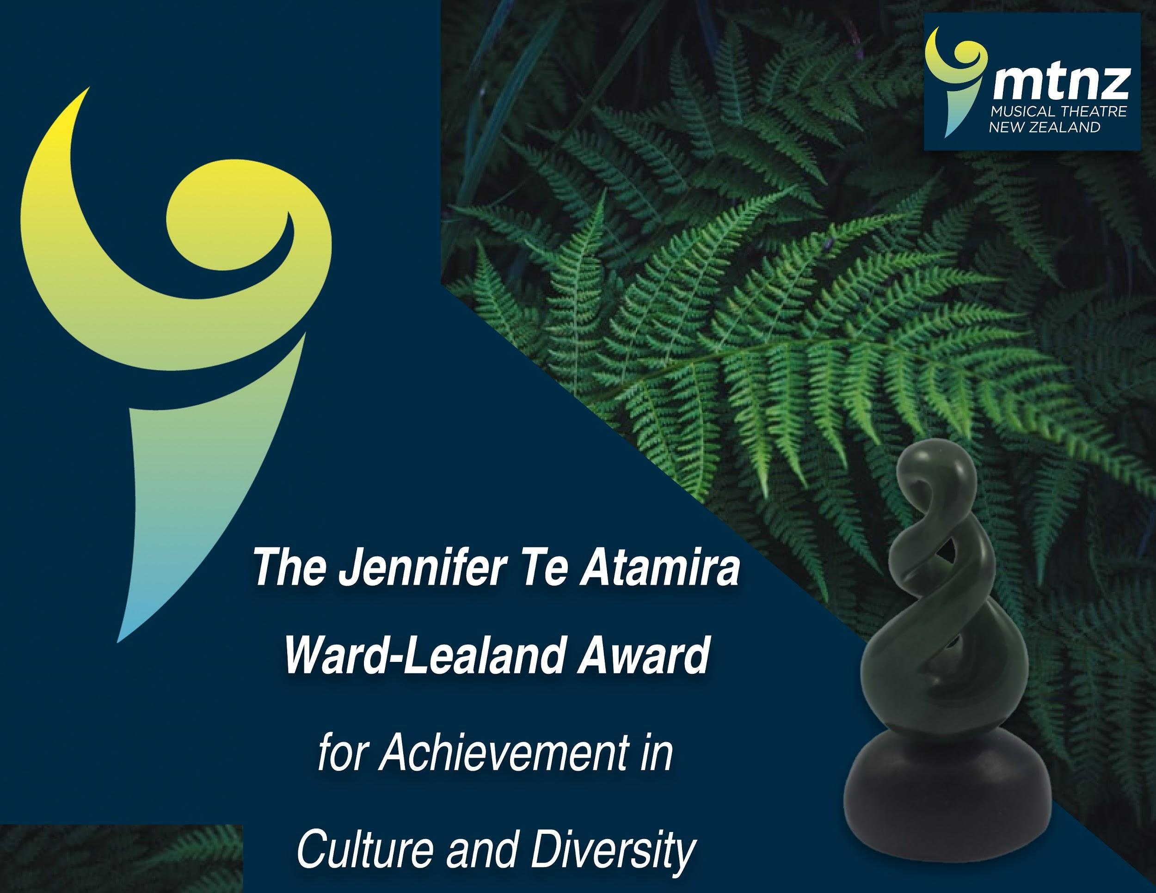

### Award descriptor:

Increasingly, societies and individuals are considering our diverse population in Aotearoa in the way they organise, celebrate and facilitate theatre here in our country; as well as growing understanding and respect for tangata whenua, principles of te ao māori and te tiriti. It is considered that advances in diversity and culture is something to celebrate and foster within Musical Theatre in New Zealand.

### Diversity Definition:

The Cambridge Dictionary defines diversity as “the fact of many different types of things or people being included in something” with this range including: race, age, cultural practise, religion, sexual orientation and gender. In this instance, included in Theatre in New Zealand.

### Award recipient:

A suitable nominee for this award would be an individual or organisation who displays a willingness to foster a culture of diversity and inclusion; someone able to recognize it as a vital aspect of theatre practise and overall society culture.

The person is nominated by a MTNZ member or a member of an MTNZ organisation. The nomination needs to be accompanied by minutes, or other similar supporting documentation.

The following is a non-exhaustive list providing examples of attributes and indicators accredited to the nominee:

* Drives or intentionally selects shows which create a platform for expanding and developing culture and inclusivity.
* Fosters cultural and inclusive change within a society/organisation; contributing to the society’s/organisation’s overall cultural practise.
* Displays a genuine respect for diverse groups and encourages engagement from diverse groups in decision making and/or participation.
* Displays consideration for diverse characteristic and requirements within the crew and members of a show.
* Demonstration of a genuine heart for diverse groups; setting an example and standard for others to follow.

### 

### Submissions and Judging:

The award is judged by the MTNZ Kaiarahi Tikanaga in collaboration with Jennifer Te Atamira Ward-Lealand where appropriate.

The nomination should be in ‘story’ format, capturing the essence, emotion and ‘mana’ of the cultural or inclusive scenario; in which the nominee displayed leadership in this field. It can be emailed through the MTNZ office - office@mtnz.co.nz

Submissions open August 31 each year and close December 31 of the following year. The award will be presented at the Friday awards function at the MTNZ national conference.

### Award:

The award will be the one year holding of the prestigious Jennifer Ward-Lealand Te Atamira Trophy (a beautiful and valued ceramic triple knot), which is returned annually, and a framed certificate to keep.

Nominees will be advised of their nomination and invited to attend conference; we encourage nominating societies to help their nominees attend conference as they will then be present to receive their prestigious award if successful.

### Nomination form for the *Jennifer Te Atamira Ward-Lealand Award for achievement in Culture and Diversity 2024*

Name of nominee:

Date:

Name of MTNZ Society or Arts Education Organisation the nominee represents:

Nominated by:

Contact email and phone number for nominee:

Kaupapa/reasoning for the nomination: (*please tell the story, help us to understand what attributes this person brings to this important mahi):*

Signed: Dated:

Name: Contact email and/or phone: